Instructions:

* This is an open-book final exam.
* Please submit this document only.

**There are two projects, each worth 50%**

**Project #1 (Chapter 11 Inheritance)**

Complete the following person and Customer classes using inheritance.

**#1 print screen the code with the output below here.**

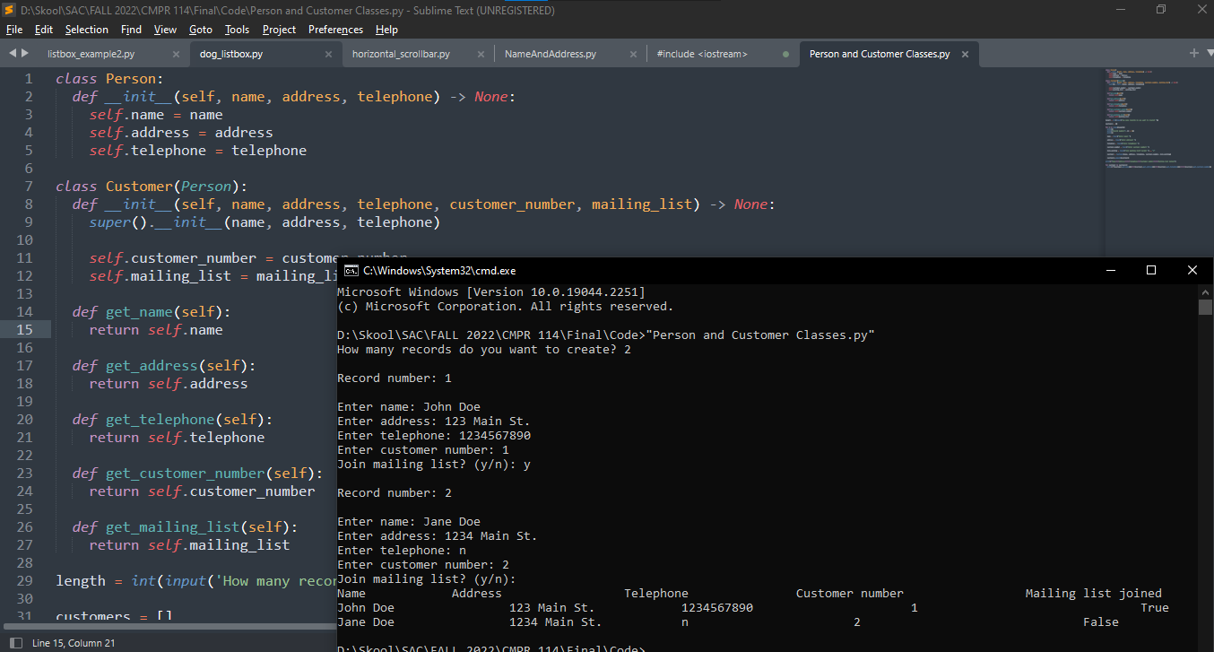

Code:

class Person:

def __init__(self, name, address, telephone) -> None:

self.name = name

self.address = address

self.telephone = telephone

class Customer(Person):

def __init__(self, name, address, telephone, customer_number, mailing_list) -> None:

super().__init__(name, address, telephone)

self.customer_number = customer_number

self.mailing_list = mailing_list

def get_name(self):

return self.name

def get_address(self):

return self.address

def get_telephone(self):

return self.telephone

def get_customer_number(self):

return self.customer_number

def get_mailing_list(self):

return self.mailing_list

length = int(input('How many records do you want to create? '))

customers = []

for i in range(length):

print()

print('Record number:', (i + 1))

print()

name = input('Enter name: ')

address = input('Enter address: ')

telephone = input('Enter telephone: ')

customer_number = input('Enter customer number: ')

join_mailing = input('Join mailing list? (y/n): ') == 'y'

customer = Customer(name, address, telephone, customer_number, join_mailing)

customers.append(customer)

print(f'Name\t\tAddress\t\t\tTelephone\t\tCustomer number\t\t\tMailing list joined')

for customer in customers:

print(f'{customer.get_name()}\t\t{customer.get_address()}\t\t{customer.get_telephone()}\t\t\t{customer.get_customer_number()}\t\t\t\t{customer.get_mailing_list()}')

**Project #2 (Chapter 13 GUI Programming & Databases)**

Create a GUI interface using Tkinter, that will accept the StudentID, Last name, First name, Address, City, State, Zip code, Gender, and age. Once the button is pressed the data will be transferred to an SQLite Table. Name the database and table any name.

**#2 print screen the code with the output below here.**

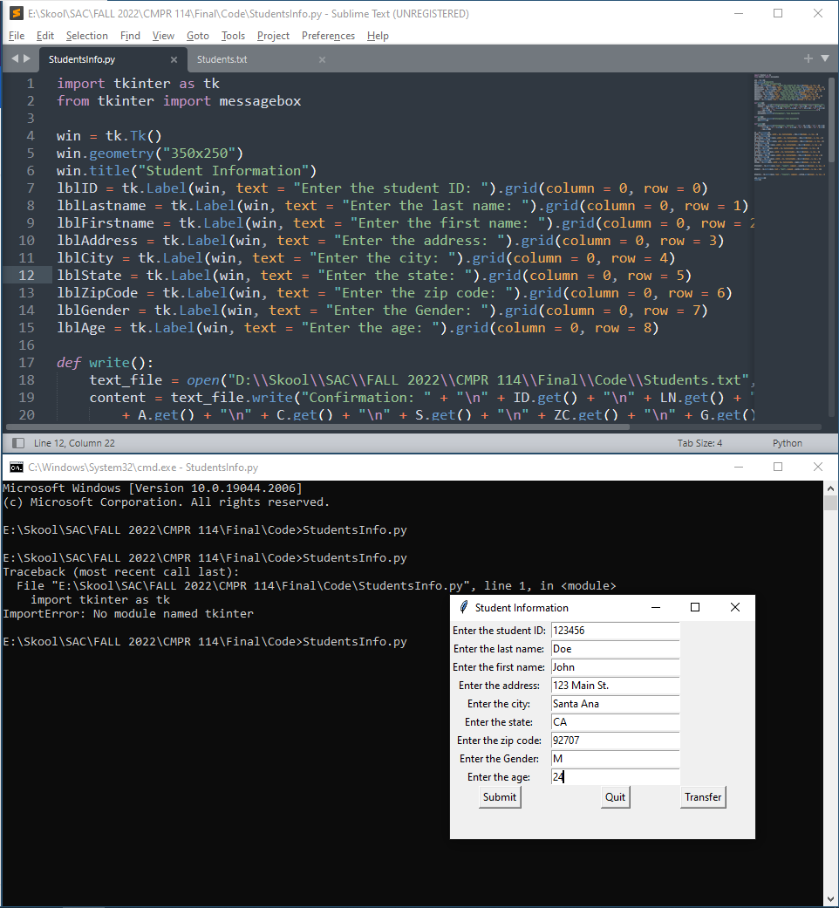

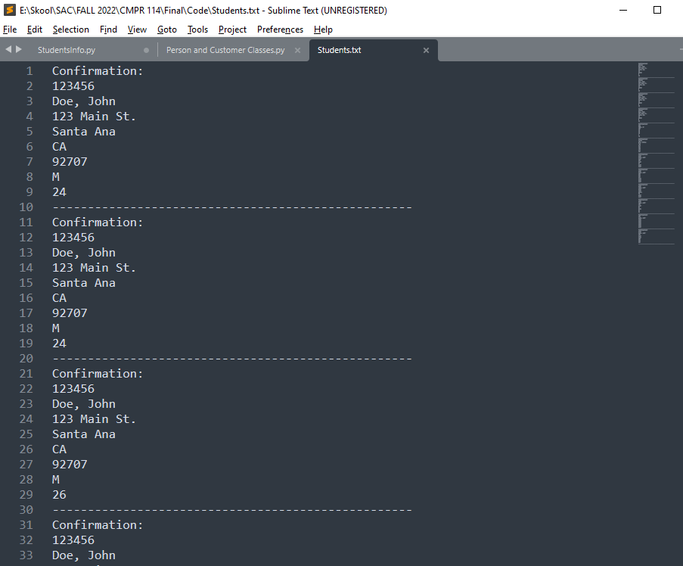

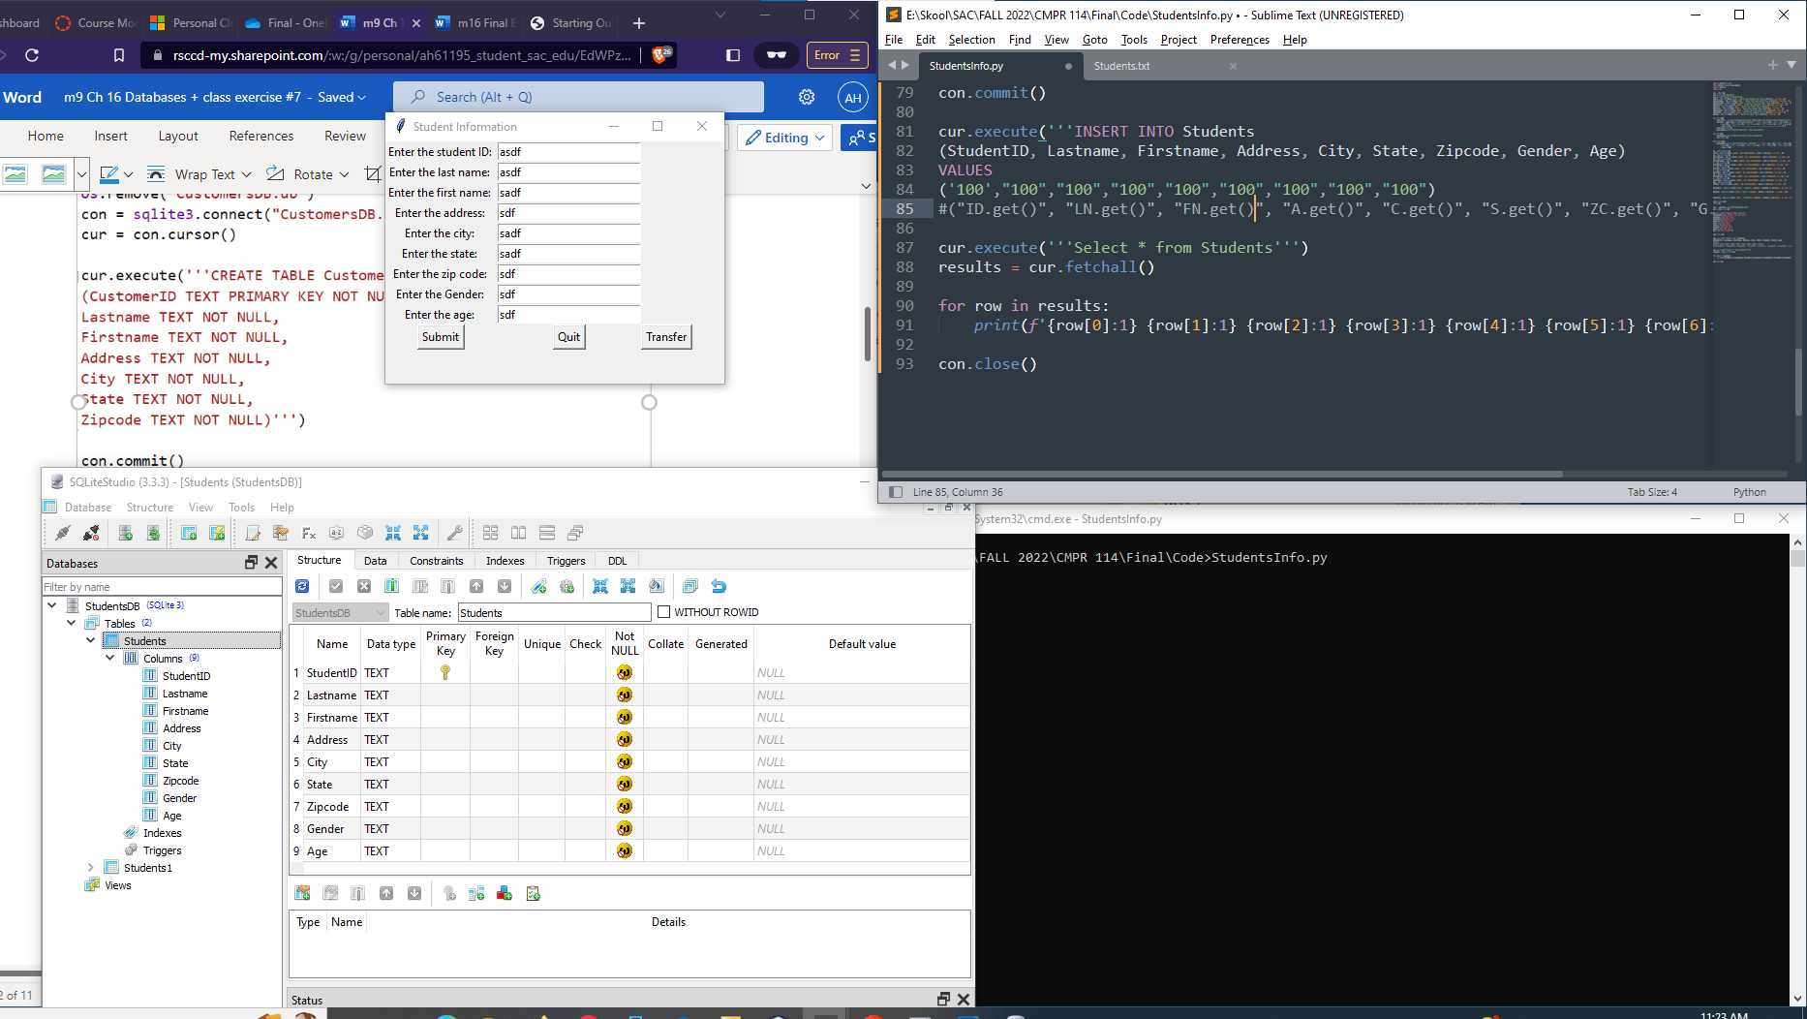

Code:

import tkinter as tk

from tkinter import messagebox

import sqlite3

import os

win = tk.Tk()

win.geometry("350x250")

win.title("Student Information")

lblID = tk.Label(win, text = "Enter the student ID: ").grid(column = 0, row = 0)

lblLastname = tk.Label(win, text = "Enter the last name: ").grid(column = 0, row = 1)

lblFirstname = tk.Label(win, text = "Enter the first name: ").grid(column = 0, row = 2)

lblAddress = tk.Label(win, text = "Enter the address: ").grid(column = 0, row = 3)

lblCity = tk.Label(win, text = "Enter the city: ").grid(column = 0, row = 4)

lblState = tk.Label(win, text = "Enter the state: ").grid(column = 0, row = 5)

lblZipCode = tk.Label(win, text = "Enter the zip code: ").grid(column = 0, row = 6)

lblGender = tk.Label(win, text = "Enter the Gender: ").grid(column = 0, row = 7)

lblAge = tk.Label(win, text = "Enter the age: ").grid(column = 0, row = 8)

def write():

text_file = open("E:\\Skool\\SAC\\FALL 2022\\CMPR 114\\Final\\Code\\Students.txt", "a")

content = text_file.write("Confirmation: " + "\n" + ID.get() + "\n" + LN.get() + ", " + FN.get() + "\n"

+ A.get() + "\n" + C.get() + "\n" + S.get() + "\n" + ZC.get() + "\n" + G.get() + "\n"

+ Age.get() + "\n---------------------------------------------------\n")

text_file.close()

messagebox.showinfo("Information", "Data Recorded")

def quit():

messagebox.showinfo("Information","Data Recorded")

win.destroy()

def submit():

messagebox.showinfo("Information", "Entered: " + "\n" + ID.get() + "\n" + LN.get() + ", " + FN.get() + "\n"

+ A.get() + "\n" + C.get() + "\n" + S.get() + "\n" + ZC.get() + "\n" + G.get() + "\n"

+ Age.get())

ID = tk.StringVar()

txtID = tk.Entry(win, width = 24, textvariable = ID).grid(column = 1, row = 0)

LN = tk.StringVar()

txtLastname = tk.Entry(win, width = 24, textvariable = LN).grid(column = 1, row = 1)

FN = tk.StringVar()

txtFirstname = tk.Entry(win, width = 24, textvariable = FN).grid(column = 1, row = 2)

A = tk.StringVar()

txtAddress = tk.Entry(win, width = 24, textvariable = A).grid(column = 1, row = 3)

C = tk.StringVar()

txtCity = tk.Entry(win, width = 24, textvariable = C).grid(column = 1, row = 4)

S = tk.StringVar()

txtState = tk.Entry(win, width = 24, textvariable = S).grid(column = 1, row = 5)

ZC = tk.StringVar()

txtZipCode = tk.Entry(win, width = 24, textvariable = ZC).grid(column = 1, row = 6)

G = tk.StringVar()

txtGender = tk.Entry(win, width = 24, textvariable = G).grid(column = 1, row = 7)

Age = tk.StringVar()

txtAge = tk.Entry(win, width = 24, textvariable = Age).grid(column = 1, row = 8)

btnSubmit = tk.Button(win, text = "Submit", command = submit).grid(column = 0, row = 10)

btnQuit = tk.Button(win, text = "Quit", command = quit).grid(column = 1, row = 10)

btnWrite = tk.Button(win, text = "Transfer", command = write).grid(column = 2, row = 10)

win.mainloop()

submit()

con = sqlite3.connect("StudentsDB.db")

cur = con.cursor()

cur.execute('''CREATE TABLE Students

(StudentID TEXT PRIMARY KEY NOT NULL,

Lastname TEXT NOT NULL,

Firstname TEXT NOT NULL,

Address TEXT NOT NULL,

City TEXT NOT NULL,

State TEXT NOT NULL,

Zipcode TEXT NOT NULL,

Gender TEXT NOT NULL,

Age TEXT NOT NULL)''')

con.commit()

cur.execute('''INSERT INTO Students

(StudentID, Lastname, Firstname, Address, City, State, Zipcode, Gender, Age)

VALUES

('100',"100","100","100","100","100","100","100","100")

#("ID.get()", "LN.get()", "FN.get()", "A.get()", "C.get()", "S.get()", "ZC.get()", "G.get()", "Age.get()" )''')

cur.execute('''Select * from Students''')

results = cur.fetchall()

for row in results:

print(f'{row[0]:1} {row[1]:1} {row[2]:1} {row[3]:1} {row[4]:1} {row[5]:1} {row[6]:1} {row[7]:1} {row[8]:1} ')

con.close()

**Submit this document to the Module 16 final exam.**